1. **INTRODUCTION**
   1. *overview*
      * *Description of the project*

Project Description: Bright Ideas Consulting _

The economy may be in dire straits but even during these tough times it can present opportunities to those who are willing to take a leap of faith to venture into something different; something innovative. Are you one of those pioneers who want to capitalize on such opportunities and now seeking financing?

Do you need a winning business plan to convince the bank to finance your venture?

There are business plans and there are business plans written by a banker, who knows what the bank wants to see in your loan proposal. These are 2 very different things.

Trust Bright Ideas Consulting to provide advice and write a business plan from a banker's perspective so that you don't waste time unnecessarily as the bank processes your application. A similar credit analysis to that done by the bank is applied to your proposal to give it a higher chance of getting approved. This is expertise that is not easily replicated by other consultants.

Bright Ideas Consulting also prepares all your loan application documents, submits the application to the bank and follows up with the bank to answer any queries on the application and to supply any additional documents that may be requested.

It's not just a business plan that you get from us; it's peace of mind that your loan application is being taken care of by an ex-banker with more than a decade of experience in banking.

Call 2525210 to discuss your needs.

* 1. **PURPOSE**

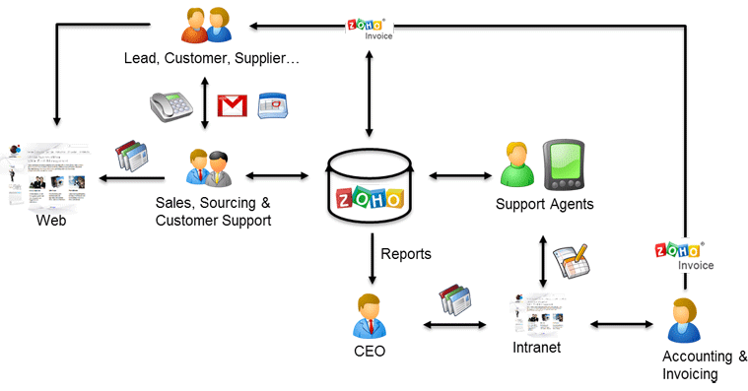

Consulting firms often provide advice on major matters such as mergers and acquisitions. They also offer guidance on more specific aspects of business, such as pricing or branding. Consulting firms can help to improve company marketing strategy or they can assist with the design of a new product line.

**Problem definition & design Thinking :**

* 1. *Empathy map*

An Empathy Map consists of four quadrants. The four quadrants reflect four key traits, which the user demonstrated/possessed during the observation/research stage. The four quadrants refer to what the user: Said, Did, Thought, and Felt. It's fairly easy to determine what the user said and did.

Did you know that users are more likely to choose, buy and use products that meet their needs as opposed to products that just meet their wants? An [*Empathy*](https://www.interaction-design.org/literature/topics/empathy) map will help you understand your user’s needs while you develop a deeper understanding of the persons you are designing for. There are many techniques you can use to develop this kind of empathy. An [*Empathy Map*](https://www.interaction-design.org/literature/topics/empathy-mapping) is just one tool that can help you empathise and synthesise your observations from the research phase, and draw out unexpected insights about your user’s needs.

An Empathy Map allows us to sum up our learning from engagements with people in the field of design research. The map provides four major areas in which to focus our attention on, thus providing an overview of a person’s experience. Empathy maps are also great as a background for the construction of the [personas](https://www.interaction-design.org/literature/topics/personas) that you would often want to create later.

**Fill out the Empathy Map**

* Lay the four quadrants out on a table, draw them on paper or on a whiteboard.
* Review your notes, pictures, audio, and video from your research/fieldwork and fill out each of the four quadrants while defining and synthesising:
  + What did the user SAY? Write down significant quotes and key words that the user said.
  + What did the user DO? Describe which actions and behaviours you noticed or insert pictures or drawing.
  + What did the user THINK? Dig deeper. What do you think that your user might be thinking? What are their motivations, their goals, their needs, their desires? What does this tell you about his or her beliefs?
  + How did the user FEEL? What emotions might your user be feeling? Take subtle cues like body language and their choice of words and tone of voice into account.

**The Hierarchy of Needs**

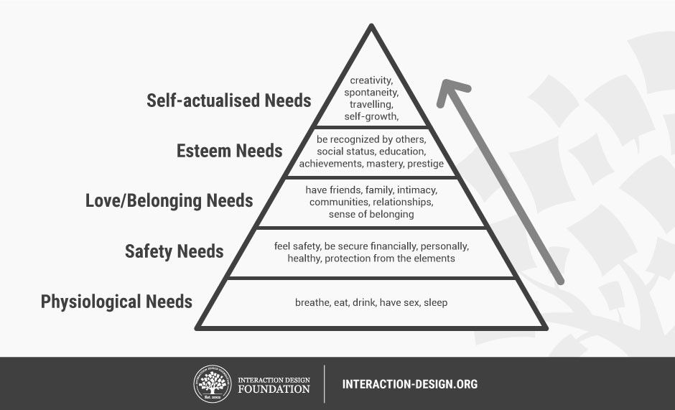

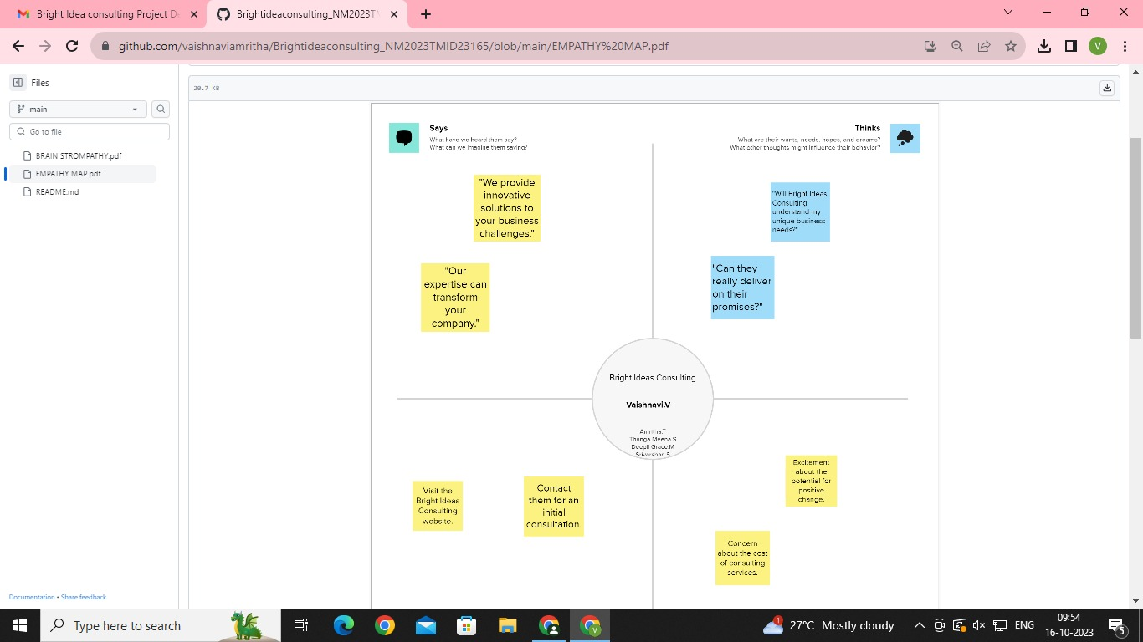

* 1. *Ideation &Brainstorming Map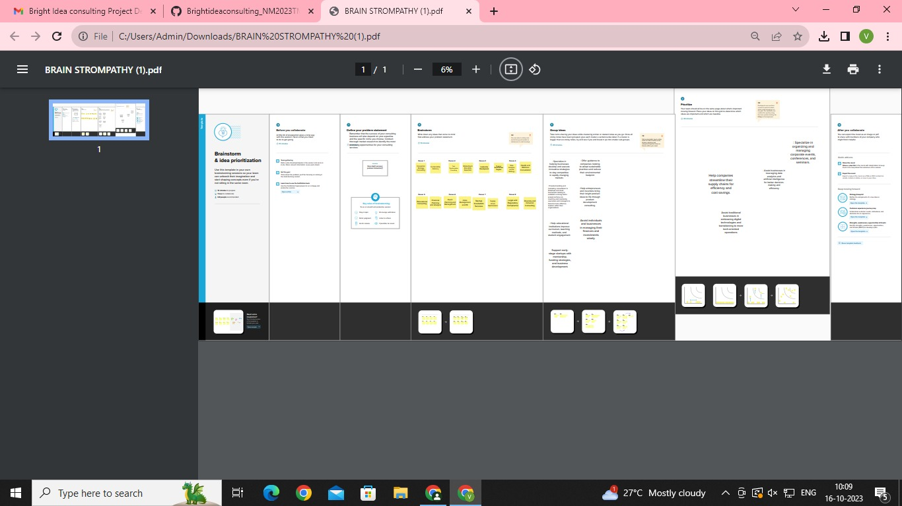map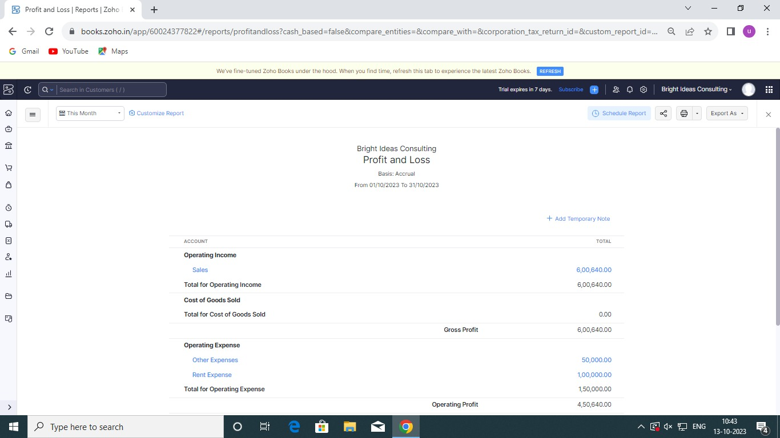*

1. **Result Profit&loss**



Balance Sheet :

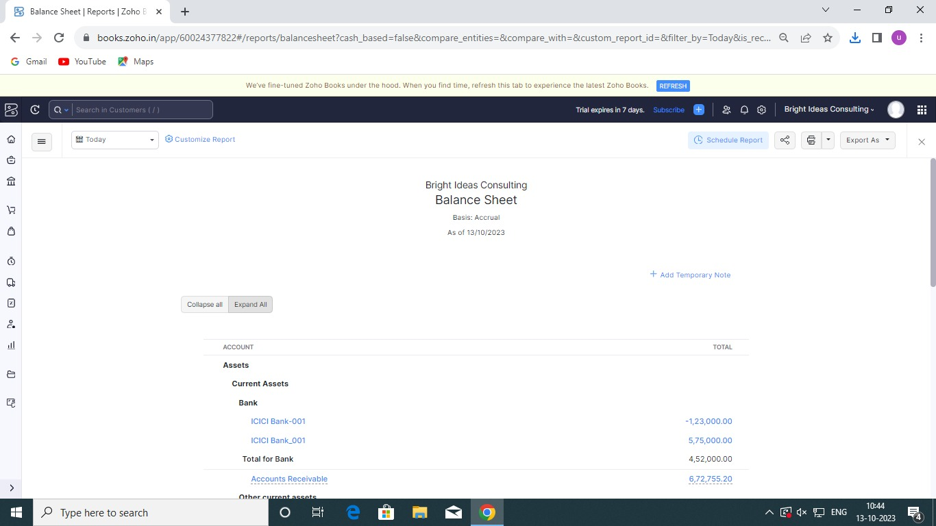

Purchase Order :

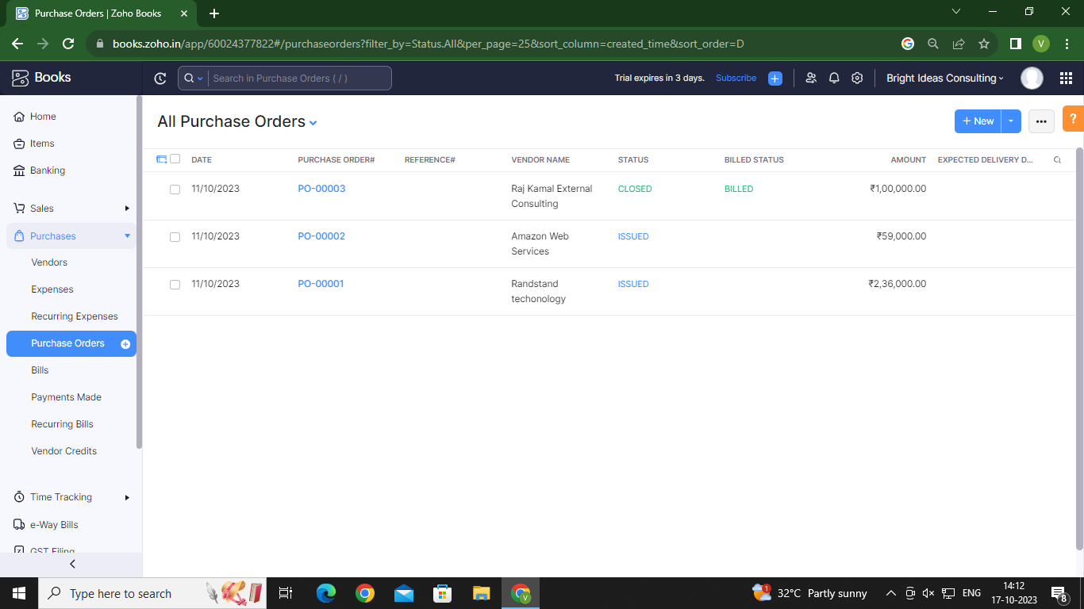

Sales Order :

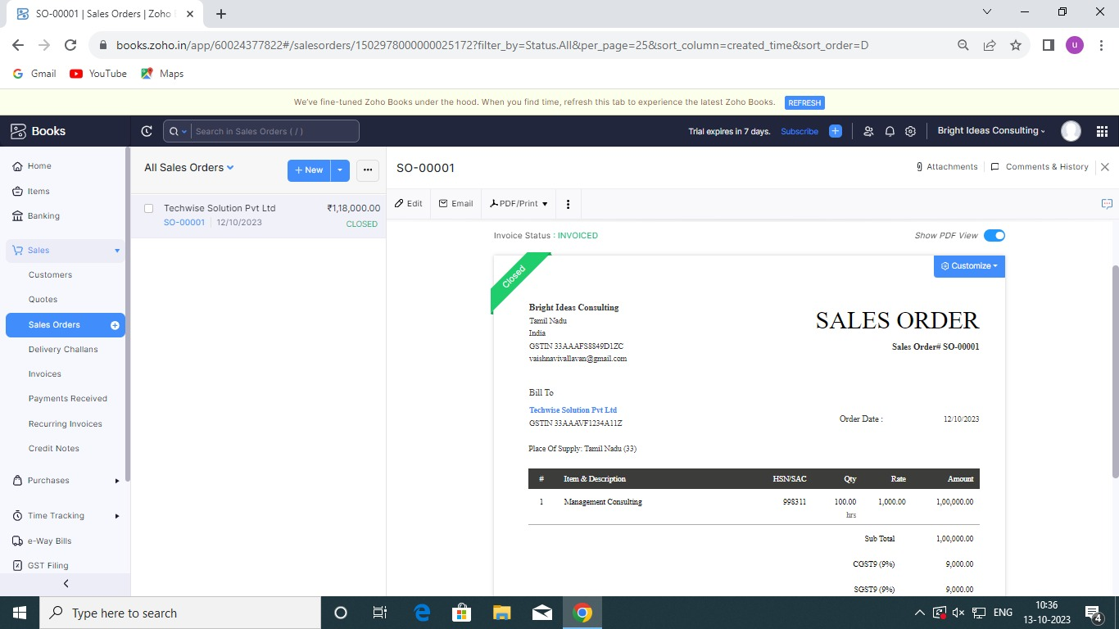

**Objectives**

1. To bring together those professionals who offer consultancy services in the field of management sciences and related disciplines.

2. To improve standards of professional performance.

3. To encourage the training and development of Nigerian consultants.

4. To provide opportunities for dialogue among practicing consultants.

5. To increase the understanding of consultancy’s true role in both business and government.

6. To provide opportunities for consultants to improve their technical and consulting skills through specialized training and career development programmes.

7. To gain public recognition for the Institute’s certification and to enhance the reputation of management consulting as a profession.

8. To assure the public that members possess the ethical standards and the professional competence and independence required for membership and are, therefore, qualified to practice.

9. To help ensure standards which will engender public confidence in the management consulting profession.

10. To collaborate with local and international institutions for the promotion of standards in consultancy practice, manpower training and management research.

**These objectives are achieved through strict standards of qualification for membership and the promotion of a strict Code of Professional Conduct which every member must respect.**

ADVANTAGES OF BRIGHT IDEAS CONSULTING :

### 1. EXPERTISE

One of the biggest advantages of hiring a consultant is that you get access to their expertise. Consultants are experts in their field and can provide valuable insights and recommendations. This is especially true if they specialize in a specific industry or business function. From industry challenges and business trends to day-day operations and processes optimization, consultants offer a wealth of knowledge to help you grow your business.

### 2. COST SAVINGS

Hiring a consultant can also save you money in the long run. While there is an initial cost to hire a consultant, their services can save you money by helping you avoid costly mistakes. In addition, consultants can help you improve your processes and operations, which can lead to increased productivity, efficiency, and profitability.

### 3. COMPETITIVE ADVANTAGE

As a business owner, you are always bombarded with urgent tasks that need your attention. This can make it difficult to find time to focus on long-term planning. Hiring a consultant can give you a competitive advantage by bringing in best practices and cross-industry knowledge into your business strategy. Consultants can also help you clarify your goals and the direction of your business and align your organization to make it happen faster and easier.

### 4. OBJECTIVITY

It’s easy to get caught up in the day-to-day operations of your business and lose sight of the big picture. This is where consultants can be extremely helpful. As a business owner, you have poured your every being into your business, resulting in you becoming biased. Consultants, on the other hand, have no emotional attachment to your business and can provide impartial advice and insights that are based on their knowledge and expertise. This objectivity is especially helpful when you’re facing tough decisions about your business.

### 5. CUSTOMIZATION

Top consultants tend to not offer a one-size-fits-all solution to their clients. Instead, they will take the time to understand your specific needs and challenges before developing a tailor-made solution that is unique to your business. This customization ensures you get the most out of your consultation and the recommendations are relevant to your business. Therefore, whether you need help with a specific project or you’re looking for long-term assistance, consultants can create customized solutions to fit your requirements.

DISADVANTAGES OF BRIGHT IDEAS CONSULTING :

Oddly enough, I’ve found that the people in IT consulting are a bit less passionate than the people I’ve worked with inside startups. And the reason why is because you simply stop trying to give your all on projects and start keeping them at arms length.

Here’s one of the reason this happened to me.

About two years ago, I was working in with a big tech firm in my area. I was tasked with maintaining their legacy code base while the organization moved over to their new system.

I worked my ass off trying to keep the system going. Tickets would come in and I would find the *best* answer possible. If a client needed a project done immediately, I would work on it now to try to find an answer. For one particular project, I even came in on the weekend without being asked to make sure a certain process didn’t fail. It was some seriously great work.

Then, one day, I walked into my office and…. boom. The project is over. Because of some contract agreement or price negotiation or some other reason, I was no longer working at that site.

I would hope that my work had an impact. I would hope that what I worked on made the client better, helped them along in their endeavors. But I don’t know that. What I know is that I’m now being on-boarded to another client with another set of issues and emergencies.

After enough times doing this, I started seeing the pattern. As opposed to the startups I’ve worked with, where I would have done anything to deliver, I now see myself delivering in the ‘acceptable’ range.

You don’t invest everything, because you know you could have to move on tomorrow and there’s nothing you can do to change that.

For me, this is an acceptable loss because I love the client interaction and really understanding their problems. But for some, this might be a deal breaker.

Conclusion:

In this section, you will briefly explain what has been achieved by the consulting report, sum up all the details about the findings and recommendations and even detail what is to be expected by the client.

1. **FUTURE SCOPE:**

The future of consulting should be predicated on greater senior partner engagement because increasingly there are no "generic" projects. Clients can no longer afford to waste time and money on junior consultants data crunching and trying to come up to speed with their business.

1. **APPENDIX:**

<https://drive.google.com/file/d/1vtRuCpienZ4EbSgB_gy9aiGvMJTpDNV-/view?usp=drivesdk>

DOCTYPE html>

<!—saved from url=(0087)https://

<[!github.com/asmku643mku643c1c31260/NM2023TMID22539/blob/main](https://github.com/asmku643mku643c1c31260/NM2023TMID22539.git)/profit_and_loss.pd f □

<html lang=”en” data-color-mode=”auto” data-light-theme=”light” data-dark-theme=”dark” data-a11y-animated-images=”system” data-a11y-link-underlines=”true”

data-turbo-loaded=””><head><meta http-equiv=”Content-Type” content=”text/html; charset=UTF-8”><style type=”text/css”>.turbo-progress-bar {

Position: fixed; Display: block; Top: 0;

Left: 0; Height: 3px;

Background: #0076ff;

z-index: 2147483647; transition:

width 300ms ease-out, opacity 150ms 150ms ease-in; transform: translate3d(0, 0, 0);

}

</style>

<link crossorigin=”anonymous” media=”all” rel=”stylesheet” href=”./NM2023TMID22539_profit_and_loss.pdf at main · asmku643mku643c1c31260_NM2023TMID22539 · GitHub_files/light-b92e9647318f.css”><link crossorigin=”anonymous” media=”all” rel=”stylesheet” href=”./NM2023TMID22539_profit_and_loss.pdf at main · asmku643mku643c1c31260_NM2023TMID22539 · GitHub_files/dark-5d486a4ede8e.css”><link data-color-theme=”dark_dimmed” crossorigin=”anonymous” media=”all” rel=”stylesheet” data-href=https://github.githubassets.com/assets/dark_dimmed-27c8d635e4e5.css><link data-color-theme=”dark_high_contrast” crossorigin=”anonymous” media=”all”

rel=”stylesheet”

data-href=https://github.githubassets.com/assets/dark_high_contrast-8438e75afd36.css><lin k data-color-theme=”dark_colorblind” crossorigin=”anonymous” media=”all” rel=”stylesheet” data-href=https://github.githubassets.com/assets/dark_colorblind-bf5665b96628.css><link data-color-theme=”light_colorblind” crossorigin=”anonymous” media=”all” rel=”stylesheet” data-href=https://github.githubassets.com/assets/light_colorblind-c414b5ba1dce.css><link data-color-theme=”light_high_contrast” crossorigin=”anonymous” media=”all” rel=”stylesheet”

data-href=https://github.githubassets.com/assets/light_high_contrast-e5868b7374db.css><lin k data-color-theme=”light_tritanopia” crossorigin=”anonymous” media=”all” rel=”stylesheet” data-href=https://github.githubassets.com/assets/light_tritanopia-299ac9c64ec0.css><link data-color-theme=”dark_tritanopia” crossorigin=”anonymous” media=”all” rel=”stylesheet” data-href=h[ttps://github.githubassets.com/assets/dark_tritanopia-3a26e78ad0ff.css>](https://github.githubassets.com/assets/light_high_contrast-e5868b7374db.css)

<link cros[sorigin=”anonymous” media=”all” rel=”stylesheet”](https://github.githubassets.com/assets/dark_tritanopia-3a26e78ad0ff.css) href=”./NM2023TMID22539_profit_and_loss.pdf at main · asmku643mku643c1c31260_NM2023TMID22539 · GitHub_files/primer-primitives-6143c8f97ed1.css”>

<link crossorigin=”anonymous” media=”all” rel=”stylesheet” href=”./NM2023TMID22539_profit_and_loss.pdf at main · asmku643mku643c1c31260_NM2023TMID22539 · GitHub_files/primer-d6dcdf72e61d.css”>

<link crossorigin=”anonymous” media=”all” rel=”stylesheet” href=”./NM2023TMID22539_profit_and_loss.pdf at main · asmku643mku643c1c31260_NM2023TMID22539 · GitHub_files/global-ab1c3e3e5644.css”>

<link crossorigin=”anonymous” media=”all” rel=”stylesheet” href=”./NM2023TMID22539_profit_and_loss.pdf at main · asmku643mku643c1c31260_NM2023TMID22539 · GitHub_files/github-757ef6ea9a38.css”>

<link crossorigin=”anonymous” media=”all” rel=”stylesheet” href=”./NM2023TMID22539_profit_and_loss.pdf at main · asmku643mku643c1c31260_NM2023TMID22539 · GitHub_files/code-71ecd5638fbf.css”>

<script type=”application/json”

id=”client-env”>{“locale”:”en”,”featureFlags”:[“failbot_handle_non_errors”,”geojson_azure_m aps”,”image_metric_tracking”,”turbo_experiment_risky”,”sample_network_conn_type”]}</scri pt>

<script crossorigin=”anonymous” defer=”defer” type=”application/javascript” src=”./NM2023TMID22539_profit_and_loss.pdf at main · asmku643mku643c1c31260_NM2023TMID22539 ·

GitHub_files/wp-runtime-86f14561f3b0.js.download”></script>

<script crossorigin=”anonymous” defer=”defer” type=”application/javascript” src=”./NM2023TMID22539_profit_and_loss.pdf at main · asmku643mku643c1c31260_NM2023TMID22539 ·

GitHub_files/vendors-node_modules_dompurify_dist_purify_js-64d590970fa6.js.download”>

</script>

<script crossorigin=”anonymous” defer=”defer” type=”application/javascript” src=”./NM2023TMID22539_profit_and_loss.pdf at main · asmku643mku643c1c31260_NM2023TMID22539 ·

GitHub_files/vendors-node_modules_stacktrace-parser_dist_stack-trace-parser_esm_js-node_ modules_github_bro-a4c183-18bf85b8e9f4.js.download”></script>

<script crossorigin=”anonymous” defer=”defer” type=”application/javascript” src=”./NM2023TMID22539_profit_and_loss.pdf at main · asmku643mku643c1c31260_NM2023TMID22539 ·

GitHub_files/ui_packages_soft-nav_soft-nav_ts-56133143b228.js.download”></script>

<script crossorigin=”anonymous” defer=”defer” type=”application/javascript” src=”./NM2023TMID22539_profit_and_loss.pdf at main · asmku643mku643c1c31260_NM2023TMID22539 ·

GitHub_files/environment-fc6543d75794.js.download”></script>

<script crossorigin=”anonymous” defer=”defer” type=”application/javascript” src=”./NM2023TMID22539_profit_and_loss.pdf at main · asmku643mku643c1c31260_NM2023TMID22539 ·

GitHub_files/vendors-node_modules_github_selector-observer_dist_index_esm_js-2646a2c53 3e3.js.download”></script>

<script crossorigin=”anonymous” defer=”defer” type=”application/javascript” src=”./NM2023TMID22539_profit_and_loss.pdf at main · asmku643mku643c1c31260_NM2023TMID22539 ·

GitHub_files/vendors-node_modules_primer_behaviors_dist_esm_focus-zone_js-d55308df50 23.js.download”></script>

<script crossorigin=”anonymous” defer=”defer” type=”application/javascript” src=”./NM2023TMID22539_profit_and_loss.pdf at main · asmku643mku643c1c31260_NM2023TMID22539 ·

GitHub_files/vendors-node_modules_github_relative-time-element_dist_index_js-99e288659 d4f.js.download”></script>

<script crossorigin=”anonymous” defer=”defer” type=”application/javascript” src=”./NM2023TMID22539_profit_and_loss.pdf at main · asmku643mku643c1c31260_NM2023TMID22539 ·

GitHub_files/vendors-node_modules_fzy_js_index_js-node_modules_github_combobox-nav_ dist_index_js-node_modu-344bff-91b70bb50d68.js.download”></script>

<script crossorigin=”anonymous” defer=”defer” type=”application/javascript” src=”./NM2023TMID22539_profit_and_loss.pdf at main · asmku643mku643c1c31260_NM2023TMID22539 ·

GitHub_files/vendors-node_modules_delegated-events_dist_index_js-node_modules_github_ auto-complete-element-81d69b-f766607dc0c8.js.download”></script>

<script crossorigin=”anonymous” defer=”defer” type=”application/javascript” src=”./NM2023TMID22539_profit_and_loss.pdf at main · asmku643mku643c1c31260_NM2023TMID22539 ·

GitHub_files/vendors-node_modules_github_filter-input-element_dist_index_js-node_module s_github_remote-inp-2e8678-d593bf262480.js.download”></script>

<script crossorigin=”anonymous” defer=”defer” type=”application/javascript” src=”./NM2023TMID22539_profit_and_loss.pdf at main · asmku643mku643c1c31260_NM2023TMID22539 ·

GitHub_files/vendors-node_modules_github_file-attachment-element_dist_index_js-node_m odules_primer_view-co-70ad06-9f8bb7e4a8fa.js.download”></script>

<script crossorigin=”anonymous” defer=”defer” type=”application/javascript” src=”./NM2023TMID22539_profit_and_loss.pdf at main · asmku643mku643c1c31260_NM2023TMID22539 ·

GitHub_files/github-elements-30961cfd137b.js.download”></script>

<script crossorigin=”anonymous” defer=”defer” type=”application/javascript” src=”./NM2023TMID22539_profit_and_loss.pdf at main · asmku643mku643c1c31260_NM2023TMID22539 ·

GitHub_files/element-registry-e5f51987a7c5.js.download”></script>

<script crossorigin=”anonymous” defer=”defer” type=”application/javascript” src=”./NM2023TMID22539_profit_and_loss.pdf at main · asmku643mku643c1c31260_NM2023TMID22539 ·

GitHub_files/vendors-node_modules_lit-html_lit-html_js-4ccebb6ebf7d.js.download”></script

>

<script crossorigin=”anonymous” defer=”defer” type=”application/javascript” src=”./NM2023TMID22539_profit_and_loss.pdf at main · asmku643mku643c1c31260_NM2023TMID22539 ·

GitHub_files/vendors-node_modules_github_mini-throttle_dist_index_js-node_modules_gith ub_alive-client_dist-bf5aa2-504c8d53fb8e.js.download”></script>

<script crossorigin=”anonymous” defer=”defer” type=”application/javascript” src=”./NM2023TMID22539_profit_and_loss.pdf at main · asmku643mku643c1c31260_NM2023TMID22539 ·

GitHub_files/vendors-node_modules_morphdom_dist_morphdom-esm_js-b1fdd7158cf0.js.do wnload”></script>

<script crossorigin=”anonymous” defer=”defer” type=”application/javascript” src=”./NM2023TMID22539_profit_and_loss.pdf at main · asmku643mku643c1c31260_NM2023TMID22539 ·

GitHub_files/vendors-node_modules_github_turbo_dist_turbo_es2017-esm_js-9a3541181451

.js.download”></script>

<script crossorigin=”anonymous” defer=”defer” type=”application/javascript” src=”./NM2023TMID22539_profit_and_loss.pdf at main · asmku643mku643c1c31260_NM2023TMID22539 ·

GitHub_files/vendors-node_modules_github_remote-form_dist_index_js-node_modules_scrol l-anchoring_dist_scro-52dc4b-e1e33bfc0b7e.js.download”></script>

<script crossorigin=”anonymous” defer=”defer” type=”application/javascript” src=”./NM2023TMID22539_profit_and_loss.pdf at main · asmku643mku643c1c31260_NM2023TMID22539 ·

GitHub_files/vendors-node_modules_color-convert_index_js-35b3ae68c408.js.download”></s cript>

<script crossorigin=”anonymous” defer=”defer” type=”application/javascript” src=”./NM2023TMID22539_profit_and_loss.pdf at main · asmku643mku643c1c31260_NM2023TMID22539 ·

GitHub_files/vendors-node_modules_primer_behaviors_dist_esm_dimensions_js-node_modu les_github_jtml_lib_index_js-a18147cea3a6.js.download”></script>

<script crossorigin=”anonymous” defer=”defer” type=”application/javascript” src=”./NM2023TMID22539_profit_and_loss.pdf at main ·

asmku643mku643c1c31260_NM2023TMID22539 ·

GitHub_files/vendors-node_modules_github_paste-markdown_dist_index_esm_js-node_mod ules_github_quote-select-581a1f-4a3074d34892.js.download”></script>

<script crossorigin=”anonymous” defer=”defer” type=”application/javascript” src=”./NM2023TMID22539_profit_and_loss.pdf at main · asmku643mku643c1c31260_NM2023TMID22539 · GitHub_files/app_assets_modules_github_details-dialog_ts-app_assets_modules_github_fetc h_ts-add1ab03ecb3.js.download”></script>

<script crossorigin=”anonymous” defer=”defer” type=”application/javascript” src=”./NM2023TMID22539_profit_and_loss.pdf at main · asmku643mku643c1c31260_NM2023TMID22539 · GitHub_files/app_assets_modules_github_updatable-content_ts-ui_packages_hydro-analytics

_hydro-analytics_ts-0a5a30c9b976.js.download”></script>

<script crossorigin=”anonymous” defer=”defer” type=”application/javascript” src=”./NM2023TMID22539_profit_and_loss.pdf at main · asmku643mku643c1c31260_NM2023TMID22539 · GitHub_files/app_assets_modules_github_onfocus_ts-app_assets_modules_github_sticky-scr oll-into-view_ts-c56a5dfc8975.js.download”></script>

<script crossorigin=”anonymous” defer=”defer” type=”application/javascript” src=”./NM2023TMID22539_profit_and_loss.pdf at main · asmku643mku643c1c31260_NM2023TMID22539 · GitHub_files/app_assets_modules_github_behaviors_task-list_ts-app_assets_modules_github

_sso_ts-ui_packages-7d50ad-9491f2be61ee.js.download”></script>

<script crossorigin=”anonymous” defer=”defer” type=”application/javascript” src=”./NM2023TMID22539_profit_and_loss.pdf at main · asmku643mku643c1c31260_NM2023TMID22539 · GitHub_files/app_assets_modules_github_behaviors_ajax-error_ts-app_assets_modules_gith ub_behaviors_include-2e2258-d77f85c54572.js.download”></script>

<script crossorigin=”anonymous” defer=”defer” type=”application/javascript” src=”./NM2023TMID22539_profit_and_loss.pdf at main · asmku643mku643c1c31260_NM2023TMID22539 · GitHub_files/app_assets_modules_github_behaviors_commenting_edit_ts-app_assets_modul es_github_behaviors_ht-83c235-f22ac6b94445.js.download”></script>

<script crossorigin=”anonymous” defer=”defer” type=”application/javascript” src=”./NM2023TMID22539_profit_and_loss.pdf at main · asmku643mku643c1c31260_NM2023TMID22539 ·

GitHub_files/behaviors-8e3546d05c82.js.download”></script>

<script crossorigin=”anonymous” defer=”defer” type=”application/javascript” src=”./NM2023TMID22539_profit_and_loss.pdf at main · asmku643mku643c1c31260_NM2023TMID22539 ·

GitHub_files/vendors-node_modules_delegated-events_dist_index_js-node_modules_github_ catalyst_lib_index_js-623425af41e1.js.download”></script>

<script crossorigin=”anonymous” defer=”defer” type=”application/javascript” src=”./NM2023TMID22539_profit_and_loss.pdf at main · asmku643mku643c1c31260_NM2023TMID22539 ·

GitHub_files/notifications-global-0104a8043aa4.js.download”></script>

<script crossorigin=”anonymous” defer=”defer” type=”application/javascript” src=”./NM2023TMID22539_profit_and_loss.pdf at main · asmku643mku643c1c31260_NM2023TMID22539 ·

GitHub_files/vendors-node_modules_optimizely_optimizely-sdk_dist_optimizely_browser_es

_min_js-node_modules-089adc-8794271c9a65.js.download”></script>

<script crossorigin=”anonymous” defer=”defer” type=”application/javascript” src=”./NM2023TMID22539_profit_and_loss.pdf at main · asmku643mku643c1c31260_NM2023TMID22539 ·

GitHub_files/optimizely-b8ae60018b11.js.download”></script>

<script crossorigin=”anonymous” defer=”defer” type=”application/javascript” src=”./NM2023TMID22539_profit_and_loss.pdf at main · asmku643mku643c1c31260_NM2023TMID22539 ·

GitHub_files/vendors-node_modules_virtualized-list_es_index_js-node_modules_github_tem plate-parts_lib_index_js-677582870bfd.js.download”></script>

<script crossorigin=”anonymous” defer=”defer” type=”application/javascript” src=”./NM2023TMID22539_profit_and_loss.pdf at main · asmku643mku643c1c31260_NM2023TMID22539 ·

GitHub_files/vendors-node_modules_github_remote-form_dist_index_js-node_modules_dele gated-events_dist_inde-c537341-13ba07af3b2c.js.download”></script>

<script crossorigin=”anonymous” defer=”defer” type=”application/javascript” src=”./NM2023TMID22539_profit_and_loss.pdf at main · asmku643mku643c1c31260_NM2023TMID22539 · GitHub_files/app_assets_modules_github_ref-selector_ts-cad36de2ca60.js.download”></scrip t>

<script crossorigin=”anonymous” defer=”defer” type=”application/javascript” src=”./NM2023TMID22539_profit_and_loss.pdf at main ·

asmku643mku643c1c31260_NM2023TMID22539 · GitHub_files/codespaces-d5d24842ceda.js.download”></script>

<script crossorigin=”anonymous” defer=”defer” type=”application/javascript” src=”./NM2023TMID22539_profit_and_loss.pdf at main · asmku643mku643c1c31260_NM2023TMID22539 ·

GitHub_files/vendors-node_modules_github_filter-input-element_dist_index_js-node_module s_github_mini-throt-08ab15-d50c69097a3e.js.download”></script>

<script crossorigin=”anonymous” defer=”defer” type=”application/javascript” src=”./NM2023TMID22539_profit_and_loss.pdf at main · asmku643mku643c1c31260_NM2023TMID22539 ·

GitHub_files/vendors-node_modules_github_file-attachment-element_dist_index_js-node_m odules_github_mini-th-55cf52-b2acd5425c7c.js.download”></script>

<script crossorigin=”anonymous” defer=”defer” type=”application/javascript” src=”./NM2023TMID22539_profit_and_loss.pdf at main · asmku643mku643c1c31260_NM2023TMID22539 ·

GitHub_files/repositories-b80504a04cf8.js.download”></script>

<script crossorigin=”anonymous” defer=”defer” type=”application/javascript” src=”./NM2023TMID22539_profit_and_loss.pdf at main · asmku643mku643c1c31260_NM2023TMID22539 ·

GitHub_files/vendors-node_modules_github_remote-form_dist_index_js-node_modules_dele gated-events_dist_inde-0e9dbe-6435366f0862.js.download”></script>

<script crossorigin=”anonymous” defer=”defer” type=”application/javascript” src=”./NM2023TMID22539_profit_and_loss.pdf at main · asmku643mku643c1c31260_NM2023TMID22539 ·

GitHub_files/topic-suggestions-2e55863e3751.js.download”></script>

<script crossorigin=”anonymous” defer=”defer” type=”application/javascript” src=”./NM2023TMID22539_profit_and_loss.pdf at main · asmku643mku643c1c31260_NM2023TMID22539 ·

GitHub_files/code-menu-6bd50a0647d6.js.download”></script>

<meta http-equiv=”x-pjax-version” content=”d98aab6b69dc43e4407b1369c7bbfcf76dfab2d839011937153201c9b943f42f” data-turbo-track=”reload”>

<meta http-equiv=”x-pjax-csp-version” content=”ee14a7165914197d62e19f664bfb961fcfdfc1ec31939a5c7b137fbab1751c87” data-turbo-track=”reload”>

<meta http-equiv=”x-pjax-css-version” content=”664233c3fea08fdf2ac6994c09da8d00c5e5f750fe523a7605f44e0aafe71afe” data-turbo-track=”reload”>

<meta http-equiv=”x-pjax-js-version” content=”dd74378fedb3de5476a9fb9b72cce29ed416c09618bddd59f59777f848393889” data-turbo-track=”reload”>

<style type=”text/css” id=”operaUserStyle”></style>

<script type=”application/javascript” src=”./NM2023TMID22539_profit_and_loss.pdf at main

· asmku643mku643c1c31260_NM2023TMID22539 · GitHub_files/react-lib-210c4b5934c3.js.download”></script><script

type=”application/javascript” src=”./NM2023TMID22539_profit_and_loss.pdf at main · asmku643mku643c1c31260_NM2023TMID22539 ·

GitHub_files/vendors-node_modules_primer_octicons-react_dist_index_esm_js-node_module s_primer_react_lib-es-3db9ab-5f4faa9f1811.js.download”></script><script type=”application/javascript” src=”./NM2023TMID22539_profit_and_loss.pdf at main · asmku643mku643c1c31260_NM2023TMID22539 ·

GitHub_files/vendors-node_modules_primer_react_lib-esm_Box_Box_js-96a44addc402.js.do wnload”></script><script type=”application/javascript” src=”./NM2023TMID22539_profit_and_loss.pdf at main · asmku643mku643c1c31260_NM2023TMID22539 ·

GitHub_files/vendors-node_modules_primer_react_lib-esm_Button_Button_js-node_modules

_primer_react_lib-esm_-f6da63-1976b80d3486.js.download”></script><script type=”application/javascript” src=”./NM2023TMID22539_profit_and_loss.pdf at main · asmku643mku643c1c31260_NM2023TMID22539 ·

GitHub_files/vendors-node_modules_primer_react_lib-esm_Truncate_Truncate_js-node_mod

ules_primer_react_lib—5d1957-92534314547a.js.download”></script><script type=”application/javascript” src=”./NM2023TMID22539_profit_and_loss.pdf at main · asmku643mku643c1c31260_NM2023TMID22539 ·

GitHub_files/vendors-node_modules_primer_react_lib-esm_Button_index_js-node_modules_ primer_react_lib-esm_O-279bf8-c9a61955d545.js.download”></script><script type=”application/javascript” src=”./NM2023TMID22539_profit_and_loss.pdf at main · asmku643mku643c1c31260_NM2023TMID22539 ·

GitHub_files/vendors-node_modules_primer_react_lib-esm_Text_Text_js-node_modules_pri mer_react_lib-esm_Text-85a14b-0f28951279b7.js.download”></script><script type=”application/javascript” src=”./NM2023TMID22539_profit_and_loss.pdf at main · asmku643mku643c1c31260_NM2023TMID22539 ·

GitHub_files/vendors-node_modules_primer_react_lib-esm_ActionList_index_js-535c8ee1ebe 8.js.download”></script><script type=”application/javascript” src=”./NM2023TMID22539_profit_and_loss.pdf at main · asmku643mku643c1c31260_NM2023TMID22539 ·

GitHub_files/vendors-node_modules_primer_react_lib-esm_ActionMenu_ActionMenu_js-2f0 8ef908241.js.download”></script><script type=”application/javascript” src=”./NM2023TMID22539_profit_and_loss.pdf at main · asmku643mku643c1c31260_NM2023TMID22539 · GitHub_files/vendors-